**COMP7507 Visualization and Visual Analytics**

**Project Report**

**Visual Analysis on the Covid-19 Pandemic**

**Recovery of Hong Kong**

Group 7

Yi Heng 3036195382

Zhong Hao 3036196984

Wang Yilin 3036197354

Zhou Xingjian 3036195148

Contents

﻿Objectives 2

﻿Highlights of Work 3

Datasets and Visualization Tool 3

Datasets 3

Visualization Tool 3

Office: vacancy, rent and beyond 4

Data Details 4

Design 4

Visualization 4

Analysis 4

Limitations and diffculites 4

Transportation 5

Data Details 5

Design 5

Visualization 5

Analysis 5

Limitations and diffculites 5

Retail Sales 5

Data Details 6

Design 6

Visualization 6

Analysis 6

Limitations and diffculites 6

Conclusion 6

Contribution & Work Plan 6

Reference 7

# ﻿Objectives

COVID-19 pandemic has impacted diverse aspects in the Hong Kong society since 2019. Whether this city has recovered to its pre-pandemic status is unobvious and difficult to observe. The concept of recovery is abstract, thus more concrete evaluations are needed.

Inspired by Loh et al., this report measures the recovery vitality of Hong Kong by three key indicators: **1)** **office price, rent and vacancy rates, 2) public transportation ridership, and 3) retail ﻿sales.** The outcome of our work is a package of data visualization workbooks with necessary interactions and analysis on these materials.

# ﻿Highlights of Work

1. ﻿Measuring the targeted topic from analysis in three comprehensive aspects;
2. Plenty of interactable visualization work;
3. Well-designed webpage with clear navigation.

# Datasets and Visualization Tool

In this part, we will briefly describe the composition of our datasets, giving an overview of the data structure of the three indicators above. Also, we will discuss the visualization tool and methodology we choose.

## Datasets

1. Office data

Office buildings are the most common location for work and thus can reflect the health of economy. There are various data related to office, among which we care the most are as follows:

* Rent (/m2 per month)
* Price (/m2)
* Vacancy rate

The data above relies on seven regions of Hong Kong where the office buildings are centralized. We keep this feature in case there are potential discrepancy among different regions.

1. Transportation

(Overview. Can follow the above for reference. Details can be given in the later part)

1. Retail Sales

(Overview. Can follow the above for reference. Details can be given in the later part)

## Visualization Tool

1. Tableau

Initially, we considered Plotly to proceed our work. However, we find it hard to merge our contributions together. In that case, we finally chose Tableau Cloud to conduct our visualization project because it can be easily used for collaborative development.

The Tableau is also good at displaying data on a map – in this case the map of Hong Kong. Although Tableau only provides geographic roles limited to province-level, we can reduce the granularity by importing Hong Kong’s space file. Tableau is also good enough for realize user interaction with simple operations on the workbook.

1. Web…?

# Office: vacancy, rent and beyond

## Data Details

Office vacancy is an intuitive indicator to reflect the demand for office space in a particular area, and the demand has close relationship to the economy status. Office vacancy rate is defined by the proportion of office vacancy (the area of non-used office) and stock (the total area of office). Another related figure is the take-up which is given by adding the completions to the vacancy figures at the beginning of the year, then subtracting the year's demolition and the year-end vacancy figures. The data can be found at the official website of Hong Kong government.

However, we can only collect year-based vacancy data, which is not detailed enough to explore the potential tendency of the demand for office space. To evaluate the tendency better, we also collect the change of rent and price of office from 2019 to 2023, of which the time granularity reaches to month. The data of rent and price comes from 7 different regions (Sheung Wan , Central, Wan Chai / Causeway Bay, North Point / Quarry Bay, Tsim Sha Tsui, Yau Ma Tei / Mong Kok, Kowloon Bay / Kwun Tong).

The raw data used the regions’ name as the column name of price and rent in 7 areas, which makes it hard to create relations between different data tables (for example, in the table of rent, column *Sheung Wan* represents the rent in Sheung Wan, while in the table of price, the same column name represents the price). In that case, we reshape the data table, adding new columns named price, rent and region, and use region as the connection between rent and price.

The data above are divided into 3 groups – A, B and C – representing the grades of the office buildings defined by the government. Grade A is the most advanced which means it is more expensive, while grade C is the least.

## Design

The best way to show the changing trends of a figure is line chart, so we built three line charts for vacancy, rent and price respectively at first. Considering that there may be unexplored features buried in different grades, we used grades as color labels and showed the data with 3 lines in different colors, each of which represented a grade. However, there were missing data that make the fluctuation of line charts have little meaning, while what we care is actually the tendency. We then rebuild the line chart of rent into scatter plot and draw three trend lines to show the changing tendency.

For the office price, missing data also result in great fluctuation. We have to sum up the data, looking from a whole perspective to reduce the fluctuation. But we would like to preserve the grade attributes, so we chose stacked bar chart to show the contributions of different grades.

With new attribute region added, it is possible to show the data on the map in Tableau. However, we failed to find Hong Kong space file with areas small enough to show our 7 regions. Finally, we have to obtain latitude and longitude information from Google Map and add it manually.

The office vacancy rate can be easily showed by line chart. By contrast, the take-up data involves comparison to the last year, which inspires us to use a bar chart similar to the stock graph.

## Visualization

We develop two dashboards to show the features above with some interactions.

Figure 1 is the dashboard of price and rent. The map on top left shows the month average price and rent of 7 regions respectively in a particular year, where the scale of the circle represents for the rent and shade represents for the price. The displayed year can be changed by dragging the slide block under the map. The right side shows the change of rent and price from 2019-2023. The change of a certain region can be observed by clicking the circles in the map.

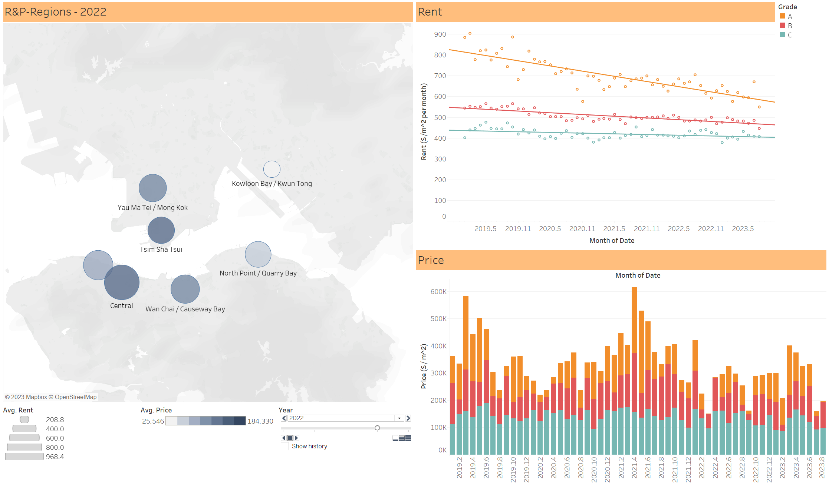

**Figure 1. Dashboard of rent and price**

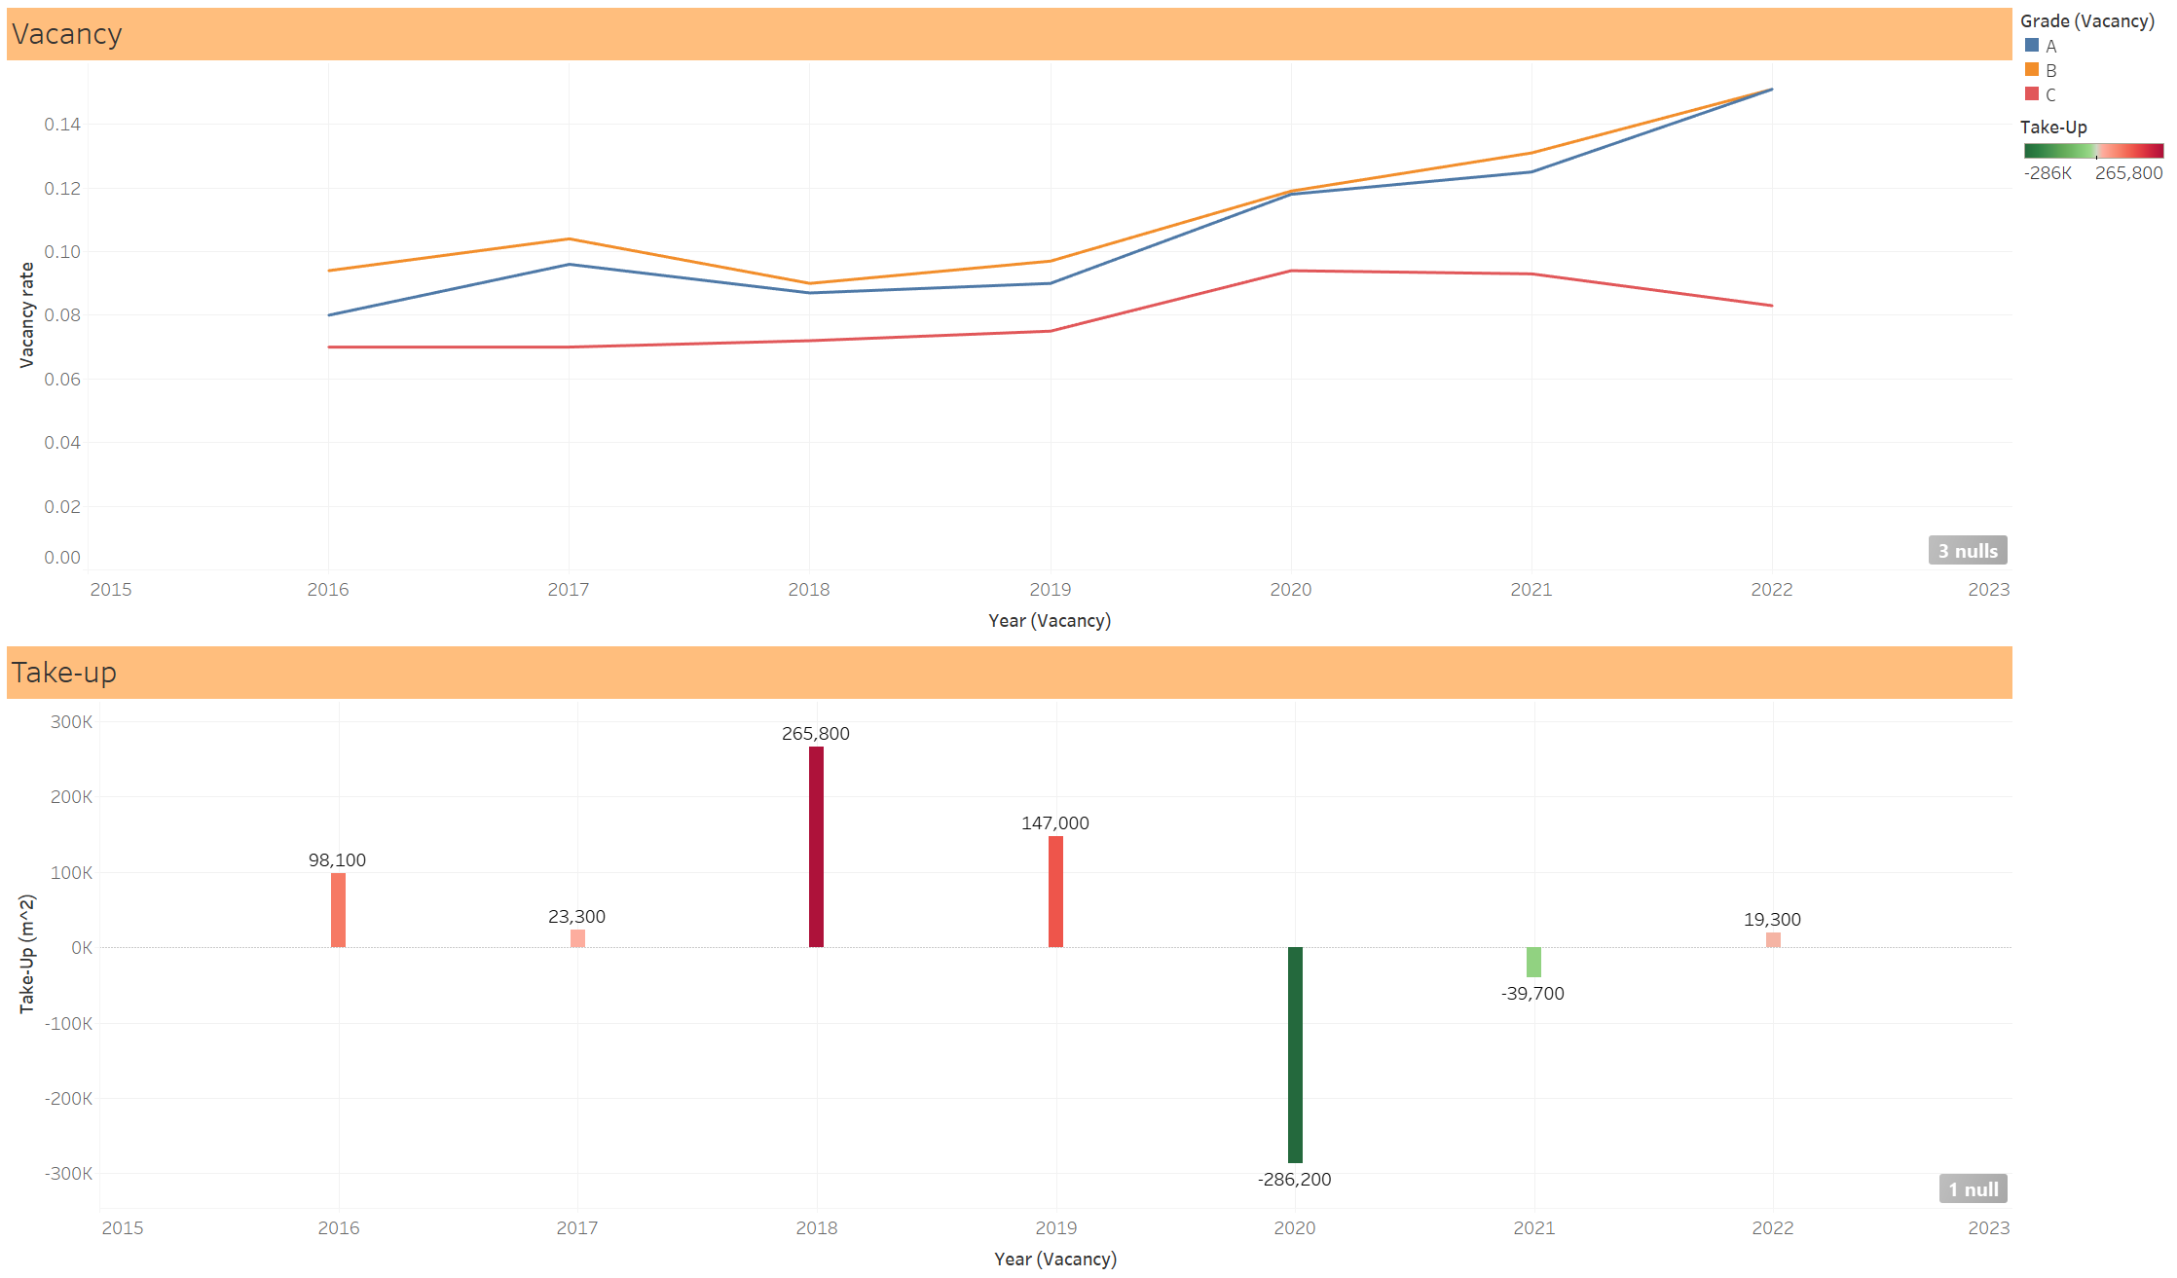

**Figure 2. Dashboard of vacancy rate**

Vacancy rate and take-up is displayed in Figure 2. The top line chart shows the vacancy rate of 3 grades, and the bottom bar chart shows the total take-up. The take-up of a certain grade can be shown by clicking on the lines from the top chart.

These two dashboards are published on the Tableau Public and can be viewed [here](https://public.tableau.com/views/Project_test_modify_vacancy_dashboard_only/sub_vacancy_rentprice?:language=en-GB&publish=yes&:display_count=n&:origin=viz_share_link), or refer to the webpage covered in the project package.

## Analysis

In Figure 1, the decreasing of rent during the pandemic period can be intuitively seen by the trend lines in the Rent-Date chart, especially for grade A, and the similar situation happens to all of the 7 regions (can be checked by clicking the circles). It seems that the impact of Covid-19 remains, indicating the economic downturn is still causing the drop of rent.

By contrast, the Price-Date chart does not show obvious relationship between price and the pandemic. One possible explanation is that the transaction of an office mainly relies on the market. That is, if the demand drops, the sellers are likely to not selling the office rather than lower the price, which agrees with the intuition.

The change of vacancy rate of grade A and B also agrees with the intuition (see Figure 2), but what seems abnormal is grade C. During the pandemic, the vacancy rate of A and B both increases, while the counterpart of C drops. In theory, the vacancy rate of all 3 grades should have increased, because the number of people who can go to work or get a job should have decreased. After analyzing, we get another way to observe this issue: people’s demand for an office space cannot be easily removed, since grade A and B has higher price and rent, people may tend to choose cheaper grade C. This is another proof of the relatively unhealthy economy.

On the other hand, the take-up’s trend is quite obvious. It can be seen that it had an extremely sharp drop in 2020, when the pandemic broke out and spread fast. After 2020, the take-up does recover a little, but haven’t return to its pre-pandemic status.

In conclusion, from the aspect of office, the impact of the pandemic still exists. All of the indicators in this part do not show recovery or do not recover to their initial conditions.

## Limitations and diffculites

* *Effectiveness of the* *visualizations (e.g., how you use them to develop hypotheses and understand/analyse data/problems)*
* *Different methods that you have tried and justification of your choices*
* *Difficulties that you have encountered, if any*
* *Anything you wanted to do but haven’t? Why?*
* *Any limitations to your visualizations and/or the tools that you used?*

# Transportation

(Suggestion: develop this part from 4 subtitles: 1) detailed data structure (the columns), 2) design and how you came up with the design (with text), 3) final outcomes (basically your tableau work, just put some images here and briefly describe them) and 4) analysis)

## Data Details

## Design

## Visualization

## Analysis

## Limitations and diffculites

* *Effectiveness of the visualizations (e.g., how you use them to develop hypotheses and understand/analyse data/problems)*
* *Different methods that you have tried and justification of your choices*
* *Difficulties that you have encountered, if any*
* *Anything you wanted to do but haven’t? Why?*
* *Any limitations to your visualizations and/or the tools that you used?*

# Retail Sales

(Suggestion: develop this part from 4 subtitles: 1) detailed data structure (the columns), 2) design and how you came up with the design, 3) final outcomes (basically your tableau work, just put some images here and briefly describe them) and 4) analysis)

## Data Details

## Design

## Visualization

## Analysis

## Limitations and diffculites

* *Effectiveness of the visualizations (e.g., how you use them to develop hypotheses and understand/analyse data/problems)*
* *Different methods that you have tried and justification of your choices*
* *Difficulties that you have encountered, if any*
* *Anything you wanted to do but haven’t? Why?*
* *Any limitations to your visualizations and/or the tools that you used?*

# Conclusion

# Contribution & Work Plan

Overview of tasks completed by each of the team members (details fo tasks should go to the individual reports from members)

|  |  |  |  |  |  |  |  |
| --- | --- | --- | --- | --- | --- | --- | --- |
|  | **Oct**  **8-15** | **Oct**  **16-23** | **Oct**  **24-31** | **Nov**  **1-8** | **Nov**  **9-16** | **Nov**  **17-24** | **Nov**  **25-30** |
| Data Preparation | X | X |  |  |  |  |  |
| Analysis of Office Vacancy Rates |  | X | X | X |  |  |  |
| Analysis of Public Transportation Ridership |  | X | X | X |  |  |  |
| Analysis of Retail Sales |  | X | X | X |  |  |  |
| Find out associations between the recovery rate and various factors |  |  | X | X | X |  |  |
| Finalize the demo |  |  |  |  | X | X |  |
| Finish the report |  |  |  |  | X | X | X |

# Reference